FORNAX™ ePlanCheck Rule
Rule Information
Rule ID | WTR 7.1.4
Rule Name | Provision of Float Valves in Storage Tanks
Chapter | 3 Storage
Section | 3.1 General
Handbook | Code of Practice for Water Services  Singapore Standard CP 48:2005  (ICS91.140.60)

Rule Description
7.1.4 Every storage tank shall be fitted with a float-operated valve, an effective adjustable valve or any other effective device for controlling the inflow of water which:
- is capable of shutting off the inflow of water at a suitable level below the overflowing level of the tank;
and

- which can be readily installed, repaired, renewed or adjusted.

Rule Interpretation
- This rule checks for the provision of valves to facilitate the flow of water in water storage tanks.
- Water storage tanks should be provided with the float valves

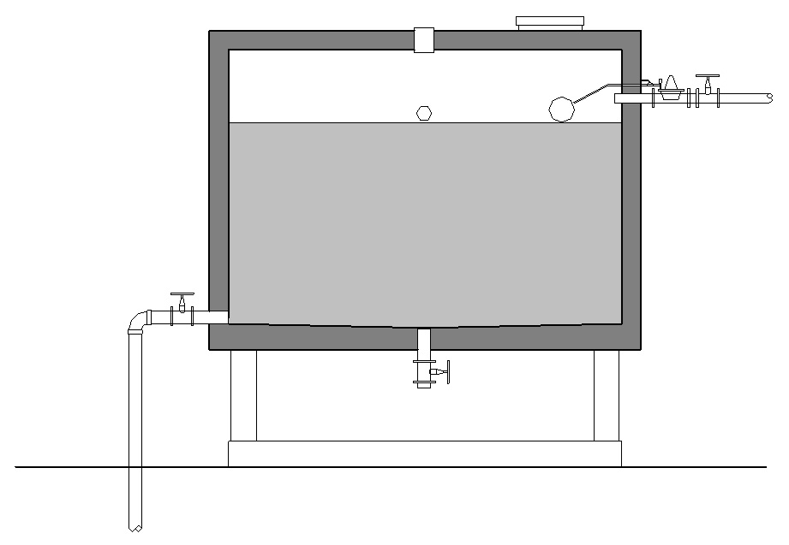

WATER STORAGE TANK WITH FLOAT VALVE
FIGURE 01

Rule Scenario

Scenario 01 – Compliant
Requirements | Float valve connected to water storage tanks
Description | Water storage tank provided with float valve
SECTION
FIGURE SCENARIO

Scenario 01 - Non-Compliant
Requirement | Float valve connected to water storage tanks
Description | Water storage tank not provided with float valve
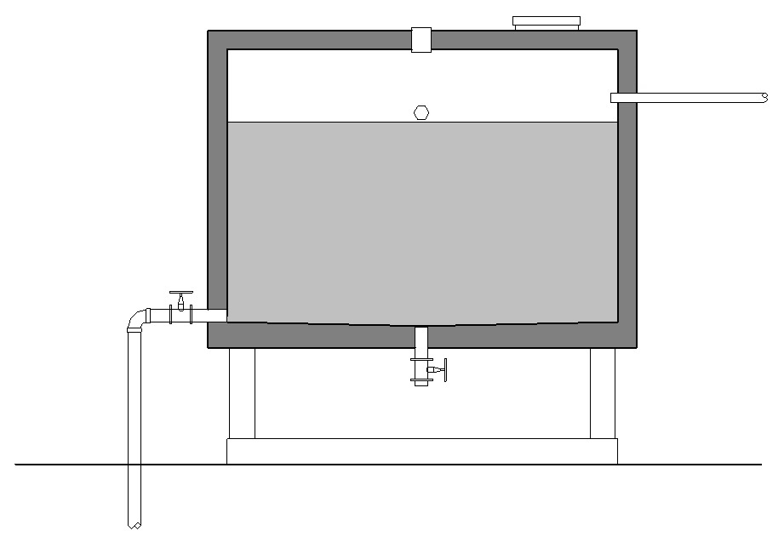

SECTION
FIGURE SCENARIO

Request For Information
- The Rule description stated in 24_Appendix 2_COP rules.pdf for WTR 7.1.4 is not found in IBS_PUB-CP 48-2005+Amd 1&2.pdf.

- We believe that the Rule stated in 24_Appendix 2_COP rules.pdf actually directs to WTR 3.1.4 in IBS_PUB-CP 48-2005+Amd 1&2.pdf. Is this correct?

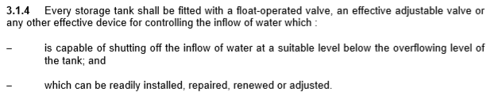

Model PreCheck

Required Elements | Required Attributes
Tank | Any
FlowController | Name contains “Float Valve”

Rule Parameters

System Type
Cold Water |  | 
Hot Water
 | Sanitary
 | Sewerage
Vent

Element Type 1
State | Type | Property | Operator | Value
Include | Tank | Name | Contains | Water Tank

Element Type 2
State | Type | Property | Operator | Value
Include | FlowController | Name | Contains | Float Valve

Element Type 1 Condition
* Should be connected to Element Type 2

Result Messages
  - WTR 7.1.4 Provision of Float Valves in Storage Tanks
  - Non-compliant (TotalResultNumeric)
    - BuildingStorey (TotalResultPerFloorNumeric)
      - ElementType2 not provided in ElementType1

  - Compliant (TotalResultNumeric)
    - BuildingStorey (TotalResultPerFloorNumeric)
      - ElementType2 provided in ElementType1

  - Attention (TotalResultNumeric)
    - Building
      - No ElementType1 found

Sample Result Messages
  - WTR 7.1.4 Provision of Float Valves in Storage Tanks
  - Non-compliant (1)
    - Level 01(1)
      - Float Valve not provided in Water Tank
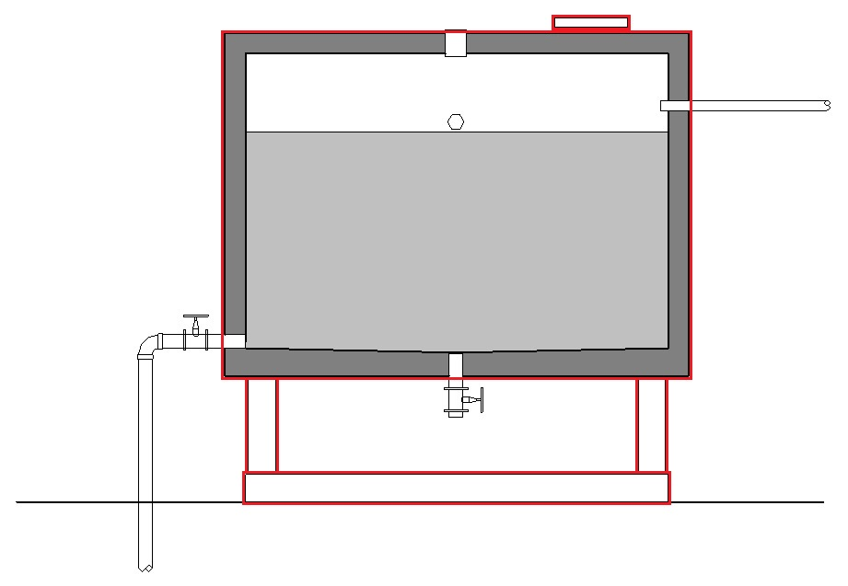
  - Compliant (1)
    - Level 01(1)
      - Float Valve provided in Water Tank
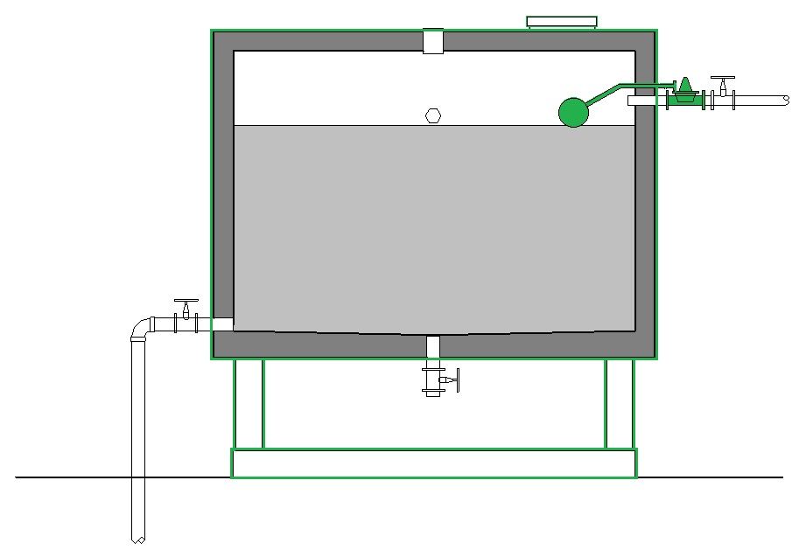

  - Attention (1)
    - Residential
      - No Water Tank found

Sample Result Model Views
- WTR 7.1.5 Overflow Pipe Diameter and Location
- Non-compliant
- Zoom in checked Tank
- Highlight checked Tank in Red
- Section view
- All other elements are translucent except checked element
- Compliant
- Zoom in checked Tank
- Highlight checked Tank in Green
- Section View
- All other elements are translucent except checked element

Testing Scenario Notes
      - Scenario 01 - Compliant
  - Water storage tank provided with float valve

      - Scenario 01 – Non Compliant
  - Water storage tank not provided with float valve

Model:
WTR 7.1.4 Compliant.ifc
WTR 7.1.4 Non-Compliant.ifc

Links:
\\revit02\SG E-Plan Checking\01-WIP\PUB\RuleSpecification_RegRule\PART B\WTR 7.1.4\001\Model\Revit\UAT

Modelling Guideline
- Specify Name containing “Water Tank” for relevant Tank.
- Specify Name containing “Float Valve” for relevant FlowController.

Specification Log
RA | Jomhar Labao
ePC version | - V1
Updates

